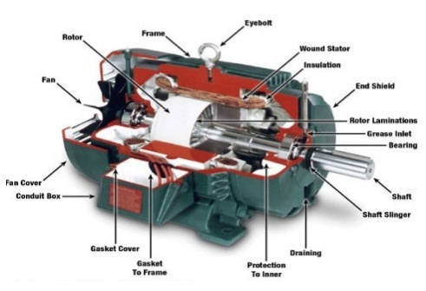

**Fig 1.a: DC machine**

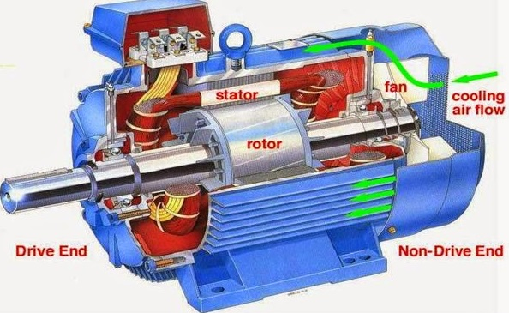

**Fig 1.b: Induction Machine**

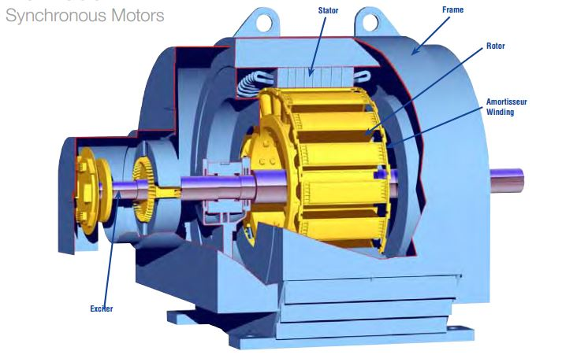

**Fig 1.c: Synchronous Machine**